**Leader Overview**



**Volume Overview**

**Be Different**

*Christians have long understood that we live and walk a fine line. We are to be in the world—all things to all people, as Paul put it—yet not of the world. God’s people have always been a chosen people, holy and set apart from the world’s ways. To pull it off, to be truly different, means we must each hold fast to the truth, speaking it when needed, all while humbling ourself and faithfully serving others.*

**Session Overview**

**Discern Truth**

*In this* **Live** *session, kids will discover the importance of truth. In a world full of competing ideas and philosophies, kids must learn to identify God’s truth and commit to be open to having their mind, heart, and life transformed by His truth.*

**Bible Lesson**

Peter Declares Who Jesus Is

[Matthew 16:13–24](https://ref.ly/logosref/Bible.Mt16.13-24)

**Faith Fact**

I can know the truth.

**Faith Verse**

[Romans 12:2](https://ref.ly/logosref/Bible.Ro12.2) (NLT)

Don’t copy the behavior and customs of this world, but let God transform you into a new person by changing the way you think.

**Preparing for the Session**

**Leader Preparation Time: 20–25 Minutes**

|  |
| --- |
| ***You Will Need***  ***Large Group***  *• Bible*  *• Worship songs (Song suggestions: “How I Praise” (Lyric Video) by Planetshakers; “I Thank God” (Lyric Video) by Maverick City Music; “Build My Life” (Lyric Video) by Housefires; “Available” (Lyric Video) by Elevation Worship)*  *• For groups not using a phone or tablet only, add:*  *• Projector or TV*  *• Laptop*  *•* ***Faith Fact Slide***  *•* ***Faith Verse Video*** *or* ***Slide***  *•* ***Bible Lesson Video***  *•* ***Teaching Point Slides 1–3***  • *Flashlight*  *• Paper, one piece per kid*  *• Pencils or pens, one per kid*  ***Small Group***  *• Bibles for kids in the group to share*  *• Kids’ Prayer and Response papers*  *• Whiteboard*  *• Dry erase markers*  *• Whiteboard eraser*  *•* ***Small Group Activity Page****, one per kid*  *• Pencils or pens, one per kid*  *To access session content and videos from a computer, visit:* [*BibleEngagementProject.com/downloads*](https://bibleengagementproject.com/downloads) |
| ***Getting Ready***  ***Large Group***  *• Download videos and slides if needed.*  *• Select worship song(s) and have them ready to play.*  *• Read the Bible Lesson Scripture to prepare for Teaching Time.*  ***Small Group***  *• Write the Faith Verse on the whiteboard.*  *• Print copies of the* ***Small Group Activity Page****, one per kid.*  ***First time leading* Live *for Kids? Check out the*** [**Facilitator Guide**](https://0b769b0ed3569ef9d18b-f88d8272f61086866d50d048b43ef630.ssl.cf2.rackcdn.com/sites/biblengagementproject/Listen_Facilitator_Guide.pdf)**.** |

**Large Group**

**30 Minutes**

*See what’s needed at the beginning of the session.*

**Introduction**

Hey, friends! I’m so excited we’re all here together. Did you know we can stand out in amazing ways when we follow Jesus? How many of you want to stand out to the world? *(Group response)* Me too!

Today we’ll hear a powerful story about Jesus’ disciples. They figured out the most important truth ever. The good news is, we can know that truth too! Now, what comes to mind when you hear the word *truth*? *(Allow responses.)*

Have you ever heard two people telling the same story in different ways? *(Group response)* Say a couple of your friends at school get in an argument. It can be hard to tell what really happened. All you know is what these two people are saying—and their stories don’t match. In times like that, it would be helpful if you could know the complete truth.

**Faith Fact**

Thankfully, there are some things we can know for sure. That’s what our Faith Fact is all about! **I can know the truth.** Truth comes from God. It’s so important to know the truth, because it helps us know what to believe and how to live.

• *Show the* ***Faith Fact Slide.***

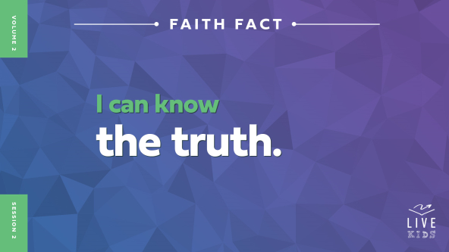

Let’s say that Faith Fact together. **I can know the truth.** Point to yourself when you say “I” and tap your head when you say “know.” Let’s try it again. **I can know the truth.**

Knowing the truth helps you see the difference between what God says and what the world says. Then you can make good choices and stand out. People will see your life is different because you know the truth.

**Game**

**True or False**

Speaking of choices, it’s time for a game! How many of you are really good guessers? *(Group response)* Here’s your chance to prove it. I’m going to share some crazy facts. Your job is to guess if they are true or false.

If you think it’s true, you’ll get up and go to that side of the room and touch the wall. *(Point to one side of the room.)* If you think it’s false, then go to that side and touch the wall. *(Point to the other side of the room.)* Ready? Let’s go!

• *Read these statements and pause to let kids choose their answers.*

1. Astronauts lose their sense of smell when they’re in space. *(Group response)* True

2. A coconut is a nut. *(Group response)* False

3. Some lizards have green blood. *(Group response)* True

4. Sound travels faster through solid steel than it travels through air. *(Group response)* True

5. Spider silk was once used to make guitar strings. *(Group response)* False.

But it has been used to make violin strings.

6. NASCAR racers can lose up to ten pounds in a single race. *(Group response)* True

7. It takes five hundred balloons to lift a person off the ground. *(Group response)* False.

It takes more than five thousand balloons to lift a person who weighs 180 pounds.

8. A penguin is a bird. *(Group response)* True

9. Our bodies have more than five hundred bones. *(Group response)* False

But we do have more than two hundred bones, which is still a lot.

10. Crocodiles cry when they eat. *(Group response)* True

• *Optional: Add some fun facts about yourself and other leaders in your church.*

Wow! Some of those facts were really tricky. It isn’t always easy to know what’s true and what’s false. If the truth isn’t clear, we might accidentally believe something false. Thankfully, the most important truth—God’s truth—can be very clear to us! His truth helps us live in an amazing way that’s totally different from the world. Let’s say our Faith Fact together as a reminder of that. **I can know the truth.**

**Worship**

We can trust that everything God says is true. Let’s thank God for showing us the truth! Who’s ready to worship God today by singing? *(Group response)* I know I am! Let’s worship Him now.

• *Lead the kids in singing one or two praise songs. See suggestions at the beginning of the session.*

**Bible Lesson**

Thanks for worshipping God with me! Singing worship songs is a great way to remind ourself of who God is. The words keep God’s truth in our mind. Worship can help us live out our Faith Fact. Say it with me. **I can know the truth**. We’re going to find out what the Bible says about God’s truth. But first, let’s pray.

**Prayer**

|  |
| --- |
| *Dear God, thanks for always leading us with love. Thank You that we can know the truth because it comes from You. Show us the truth you want us to learn from Your Word today. In Jesus’ name we pray. Amen.* |

**Video Intro**

Just before we check out the Bible story, let’s watch this video and see what Dash is up to.

• *Play* ***Bible Lesson Video****.*

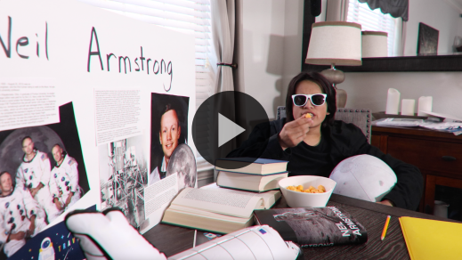

**Bible Story**

**Peter Declares Who Jesus Is**

Dash did a great job of sharing the truth with Finn kindly, even though it might have been scary. People don’t always agree about what’s true. But we can trust God’s Word. It’s true and super helpful in our everyday life. Let’s dive into it now!

**Teaching Time**

|  |
| --- |
| ***You Will Need***  *• Flashlight*  *No prep is needed for this activity.* |

In today’s Bible story, Jesus asked His disciples some questions. Remember, the disciples were Jesus’ closest followers. Jesus asked them what people were saying about Him.

People had lots of opinions about Jesus. Do you know what an *opinion* is? An opinion is what someone thinks. Your opinion may be that blue is the best color, but someone else may have the opinion that red or green is the best.

Well, many people had opinions about Jesus that were wrong. But Jesus wanted His disciples to know the truth about Him. That way, they could tell everyone else the truth when the time was right. Let’s find out more.

Imagine you lived in Bible times. Do you think it would have been hard or easy for you to trust that Jesus was God’s Son? Raise your hand if you think it would have been hard to believe in Him. *(Group response)* Raise your hand if you think it would have been easy to believe in Him. *(Group response)* Some people trusted Jesus right away. But others had trouble believing in Jesus even after He worked miracles right in front of them. It might seem crazy, but some people couldn’t see the truth. Why do you think they had trouble believing in Jesus? *(Allow responses.)*

Sometimes people today have trouble believing in Jesus too, even after He’s done amazing things. That’s why it’s so important to know the truth. Let’s say our Faith Fact together. **I can know the truth.**

Grab your Bible or pull a Bible app up on your device. Turn to [Matthew 16:13–24](https://ref.ly/logosref/Bible.Mt16.13-24).

• *In order to keep Large Group time moving along, we recommend that the leader reads the Scripture portions aloud.*

• *Optional: Remind the kids to mark this place with a bookmark, so they can read it on their own at home.*

**1. Many people didn’t know who Jesus was.**

• *Show the* ***Teaching Point 1 Slide.***

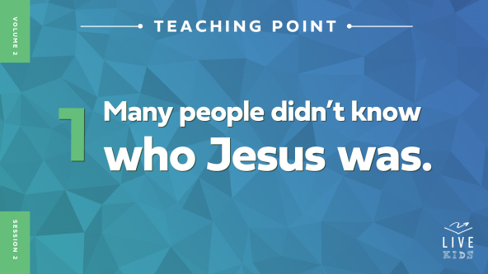

• *Read* [*Matthew 16:13–14*](https://ref.ly/logosref/Bible.Mt16.13-14)*.*

What did Jesus ask His disciples about? *(Allow responses.)* Jesus asked His disciples who people were saying that He was. The disciples listed a few names they had heard people mention. They were decent guesses, but they weren’t the truth. Jesus couldn’t have been John the Baptist. John was the one who had baptized Jesus, and lots of people saw it happen. And Jesus wasn’t Elijah or Jeremiah or another Old Testament prophet. They had lived hundreds of years before Jesus was born. Jesus was special and unique. Even though He was kind of like those other people, He was someone completely different.

Think about it this way. Imagine there was a superhero costume party at your school. You walk in, and your principal is dressed up as Iron Man. That would be cool, right? *(Group response)* But you would know your principal was just wearing a costume. Just because your principal *looked* like Iron Man didn’t mean your principal *was* Iron Man.

It was the opposite with Jesus. People thought Jesus looked like a godly man and a good teacher. He did miracles. He spoke powerful words. And He really loved people. But they didn’t understand what was really going on. Jesus was more than just another teacher or prophet. He didn’t just *look like* the Son of God. He *was* the Son of God!

Not many people could see that Jesus was God’s Son. Let’s find out about one of those who could.

**2. God showed Peter the truth about Jesus.**

• *Show the* ***Teaching Point 2 Slide.***

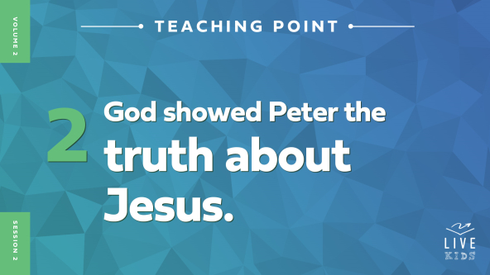

• *Read* [*Matthew 16:15–20*](https://ref.ly/logosref/Bible.Mt16.15-20)*.*

Jesus didn’t just ask what *other* people thought about Him. Jesus asked His disciples who *they* thought He was. Peter was the one who answered. He said Jesus was the Messiah, the One God had sent with a special mission. And Jesus’ mission was saving the world. Then Peter said Jesus was God’s Son. Bingo! That was the right answer!

Jesus told Peter that his answer had come from God. Then Jesus said God would use Peter in a powerful way to share the truth about Jesus. How do you think Peter felt after hearing all this? *(Allow responses.)* Maybe Peter was thinking, *“Me? You want to use* me*?”* Maybe he felt excited, nervous, confused, and not quite ready all at the same time!

Do you think people can know who Jesus is if God doesn’t help? *(Group response)* The Bible tells us no one starts following Jesus unless God helps them want to follow Him. Peter wasn’t being extra smart when he realized who Jesus was. God had helped him. God showed Peter the truth!

• *Grab your flashlight and turn off the lights.*

Before God showed Peter who Jesus was, it was like Peter was in the dark. There’s no way he could have figured out things all by himself. But when God shows us the truth, it’s like turning on a flashlight. *(Turn on the flashlight.)* Then we can clearly see who Jesus is!

• *Turn the room lights back on and put away the flashlight.*

When you have good news, who’s the first person you tell? Shout out who it is. *(Group response)* In our Bible story, the disciples had found out really good news about Jesus. He was the Messiah! But what did Jesus tell His disciples to do with that news? *(Allow responses.)* He said not to tell anyone. That would have been a hard secret to keep!

Why do you think Jesus told the disciples not to tell people He was the Messiah? *(Allow responses.)* God had a big plan to save the world through Jesus. And Jesus knew His true identity as the Messiah had to be revealed at just the right time. Jesus wanted to make sure the disciples knew who He was. Then when the time was right, they could tell everyone else.

So God showed Peter who Jesus really was—the Messiah. And Peter and the other disciples knew this amazing truth would change their lives. But was there anything hard about learning this truth? Let’s find out.

**3. The truth Jesus taught wasn’t always easy to hear.**

• *Show the* ***Teaching Point 3 Slide.***

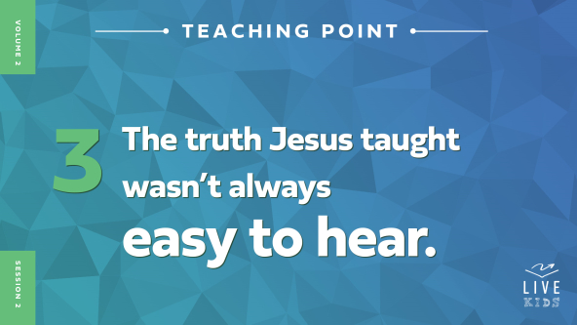

• *Read* [*Matthew 16:21–24*](https://ref.ly/logosref/Bible.Mt16.21-24)*.*

Wow! Everyone, take a deep breath. *(Group response)* Now let it out. *(Group response)* That was intense! So let’s look at all this little by little. God will help us understand the truth.

Jesus told His disciples something that wasn’t easy to hear. He was going to die a horrible death and then be raised from the dead. Have you ever known anyone besides Jesus who died and came back to life? *(Group response)* I haven’t. It’s not something that normally happens. So the disciples probably didn’t completely understand this truth Jesus was telling them.

How do you think Peter and the other disciples felt? *(Allow responses.)* I think they may have felt confused, scared, and frustrated. They didn’t like what they were hearing. They didn’t want Jesus to die. It wasn’t what they thought was going to happen. But even though it wasn’t easy to hear, Jesus wanted them to know the truth. Peter was upset with Jesus and didn’t want to believe the truth. But Jesus said Peter was seeing things from a human point of view, not God’s.

Can you think of a time you’d want to know the truth, even if it was hard? Here are a few silly examples. Say you had a piece of lettuce stuck in your teeth. Would you want someone to tell you so you could get it out? *(Group response)* Say you missed all your spelling words. Would you want your teacher to tell you so you didn’t misspell those words for the rest of your life? *(Group response)* Say your brother or sister broke your favorite toy or video game. Would you want them to tell you the truth right away? *(Group response)*

Jesus knew His disciples needed to hear the truth, even if it made them sad or upset. He had to die to rescue us from sin, but He would come back from the dead! Then Jesus told the disciples another hard truth: If they wanted to follow Him, they had to do what Jesus did. They had to give up their own plans and follow Him no matter what.

Jesus wants us to know this truth too. Here’s the cool part: If we are *following* Jesus, that means He is ahead of us. We’re never alone, even when it feels like it. Remember our Faith Fact today: **I can know the truth**. The truth is, Jesus is God’s Son. The truth is, God shows us who Jesus is. And the truth is, when we’re following Jesus, He’s always with us.

**Prayer and Response**

*Consider playing a worship song softly in the background while kids pray.*

|  |
| --- |
| ***You Will Need***  *• Paper, one sheet per kid*  *• Pencils or pens, one per kid*  *No prep is needed for this activity.* |

Sometimes it’s exciting to know the truth—like when God showed Peter that Jesus was the Messiah. And sometimes it’s hard to know the truth—like when Jesus told the disciples He would die. But God wants us to know the truth so we can do our best to follow Him.

We can sometimes make mistakes and believe lies about who Jesus is or who we are. Maybe someone told you that Jesus isn’t God’s Son or Jesus doesn’t love you. Maybe someone said mean things about the way you look or about your family. It can be easy to mess up and start believing lies instead of God’s truth.

So today, we’re going to ask God, “What truth do You want me to believe?” Then we’ll stop and listen. The truth from God could be about Him, about you, about your family, or anything. Maybe you need to believe the truth that Jesus loves you even when you’ve done something wrong. Maybe you need to believe the truth that Jesus died for you, so you could live forever with Him. Maybe you need to believe the truth that God has a special purpose just for you.

Listen carefully to the thoughts in your mind and your heart. Lots of times, that’s how God speaks to us! When you know what God wants you to believe, write it down.

• *Give each kid a sheet of paper and a pencil or pen.*

• *Optional: Give kids the opportunity to share what they heard from God.*

• *Be sensitive to the Holy Spirit’s leading if any kids are ready to ask Jesus to be their Savior.*

**Prayer**

*Optional: Have the kids repeat phrases of the prayer after you.*

|  |
| --- |
| *Dear God, thank You for showing me the truth I need to know today. Help me live it out every day. In Jesus’ name I pray. Amen.* |

**Faith Verse**

Our Faith Verse is full of truth. It’s all about being different from the world in the best way—by letting God change how we think and act! Let’s practice our verse together.

• *Play* ***Faith Verse Video****.*

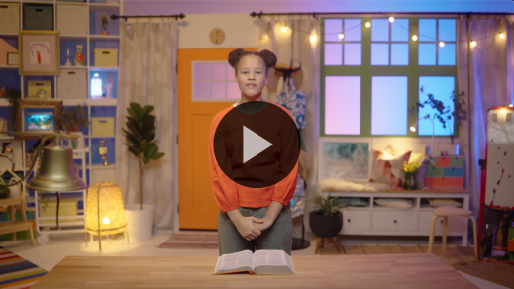

[Romans 12:2](https://ref.ly/logosref/Bible.Ro12.2) (NLT)

Don’t copy the behavior and customs of this world, but let God transform you into a new person by changing the way you think.

Living out this Faith Verse can be hard, don’t you think? *(Group response)* Well, let’s add another challenge as we say it again. Balance on one foot, and let’s say it together! *(Group response)* Now balance on the other foot, and let’s say it one more time. *(Group response)* Great job!

**Faith Fact**

Before we move on, let’s review our Faith Fact again. **I can know the truth.**

• *Show the* ***Faith Fact Slide****.*



As we say it again, point to yourself when you say “I” and tap your head when you say “know.” Let’s say it together. **I can know the truth.**

• *Dismiss kids to Small Group time or to go home if your group time ends here.*

**Small Group**

**30 Minutes**

*This section can be done in conjunction with the large group or on its own if you do small groups with your kids. During Small Group time, the goal is to connect the kids with the Word of God and to each other. All activities are led by the small group leader.*

**Group Connection**

**Spot the Truth**

|  |
| --- |
| *No prep is needed for this activity.* |

In our Bible story, Peter said the truth that Jesus is the Son of God. But many other people didn’t know the truth yet. They thought Jesus was someone else. We’re going to see if we can spot the truth like the disciples did. Only we’re going to spot the truth about each other.

Each person will share one true thing about themselves and one made-up thing. Everyone else will vote on which statement was true.

• *Start by sharing your true and false statements.*

• *Go around the group, letting kids each share one true thing and one untrue thing about themselves.*

• *Allow others in the group to vote on which statement is true before the kid reveals the truth.*

• *Make sure everyone has a chance to share at least once.*

Were you good at spotting the truth? *(Group response)* The best way to know if something is true in your life is to see if it lines up with God’s Word. Everything the Bible teaches is 100 percent true. And if something goes against what the Bible says, it’s not the truth.

**Bible Lesson Recap**

• *If small group activities are not immediately following large group time, you may want to read the Bible story passage before the discussion.*

|  |
| --- |
| ***You Will Need***  *• Bibles for kids in the group to share*  *No prep is needed for this activity.* |

**Bible Story Review: Peter Declares Who Jesus Is** [**Matthew 16:13–24**](https://ref.ly/logosref/Bible.Mt16.13-24)

What was the most interesting thing about today’s Bible story? *(Allow responses.)* Those are great answers! When Jesus asked His disciples who they thought He was, what did Peter say? *(Allow responses.)* Right! Peter told Jesus that He was the Messiah, the living God’s Son. Later, Jesus told them He was going to die and be raised to life again. Let’s talk more about the story together.

• *Optional: Give each kid a Bible and read the Bible story together.*

**Group Discussion**

*Feel free to use all or just a few questions as a jumping-off place for good discussion. Questions marked with * are designed for more conversation. Adjust the questions based on the age or maturity of your group. Typically, older kids will be able to dive a little deeper than younger ones.*

**Questions**

What’s the first question Jesus asked the disciples? What was their answer?

Why do you think people thought Jesus was John the Baptist or a prophet?

How did Peter know who Jesus was?

What truth did Jesus tell the disciples that wasn’t easy to hear?

Why do you think Peter was so upset to hear this difficult truth?

* How do you think Jesus’ followers felt about the exciting truth they knew—that Jesus was the Messiah?

* How do you think they felt about the hard truth they knew—that He would die?

* How can we know who Jesus is?

* Would you rather be told a hard truth about something or not hear the truth at all? Why?

* How can knowing the truth show others that we are different from the rest of the world?

**Live It**

|  |
| --- |
| ***You Will Need***  *• Kids’ Prayer and Response papers*  *No prep is needed for this activity.* |

**Faith Fact**

Our Faith Fact today is such an important reminder of what God wants for us. **I can know the truth.** And our Bible story helped us learn a few amazing truths—Jesus is God’s Son, and He died for us.

Even if we know the truth, it can be difficult to live it out. Sometimes we have a hard time really believing the truth. Other times we just forget it. Even if we know what’s true, we might not be brave enough to share it. But we can keep reminding ourself of the truth every day so that it sticks in our heart and mind.

**Challenge**

Earlier we asked God to remind us of a truth He wants us to know. Remember writing it down?

• *Optional: Have kids look at their paper.*

Your challenge is to take your paper home and find a Bible verse that supports the truth God reminded you of. You can ask your parent or another trusted adult for help if you need to. Then write out the verse on the back of your paper. Put it somewhere that you’ll see it every day, so you can remember the truth God wants you to know.

**Prayer**

*Finish group discussion by sharing prayer requests and praise reports. Keep track of your small group’s prayer requests and review them each time you meet.*

• *Have kids share and pray for each other’s prayer requests.*

|  |
| --- |
| *Dear God, thank You for showing us the truth that we need to know, whether it’s easy or hard to hear. We want to follow You and know Your truth. Help us do that every day. In Jesus’ name we pray. Amen.* |

**Faith Verse Review**

|  |
| --- |
| ***You Will Need***  *• Whiteboard*  *• Dry erase markers*  *• Whiteboard eraser*  ***Getting Ready***  *• Write the Faith Verse on the whiteboard.* |

Our Faith Verse is [Romans 12:2](https://ref.ly/logosref/Bible.Ro12.2). It’s a great reminder that God’s truth changes how we think. Let’s practice the verse together.

• *Show* ***Faith Verse Video****.*



[Romans 12:2](https://ref.ly/logosref/Bible.Ro12.2) (NLT)

Don’t copy the behavior and customs of this world, but let God transform you into a new person by changing the way you think.

**Faith Verse Fun**

**Word Wipeout**

When God changes the way we think, we can honor Him better and live out His Word. Let’s keep thinking about our Faith Verse during this game.

I’ve written the verse on the board, so let’s read it together one time to keep it fresh in our mind. Pay attention because we’re about to challenge our memory.

• *Read the verse together.*

Now we’ll take turns erasing words and replacing them with lines. And then we’ll try to say the verse again. Let’s see if we can keep saying it as the words disappear.

• *Have the group say the verse. Then have a volunteer come up and erase one word and replace it with a line.*

• *Repeat until the whole verse is gone.*

• *If you’re short on time, consider erasing multiple words at a time.*

Great job, everyone! Memorizing this Faith Verse will remind you to let God transform your mind so you can know the truth.

**Activity Page**

**Verse Maze**

|  |
| --- |
| ***You Will Need***  *•* ***Small Group Activity Page****, one per kid*  *• Pencils or pens, one per kid*  ***Getting Ready***  *• Print copies of the* ***Small Group Activity Page****, one per kid.* |

Our Faith Fact today is **I can know the truth.** But sometimes it can be hard to focus on the truth when other people don’t believe it. That’s where our Faith Verse comes in.

• *Hand out a copy of the* ***Small Group******Activity Page*** *and a pencil to each kid.*

This maze will remind you to not get distracted but to focus on God’s truth. When we know the truth, it guides our steps. Try to find your way through this maze using the Faith Verse.

• *Help kids with the maze as needed.*

**Dismissal**

Remember, God wants us to be different from the rest of the world in the best way possible. By knowing the truth about Jesus and sharing it with others, we stand out in any crowd!

**Prayer**

|  |
| --- |
| *Dear God, please help us to know the truth. Help us to believe the truth even when other people don’t. Help us to follow Your truth even when it’s difficult. Amen.* |

**Faith Fact Recap**

• *Show the* ***Faith Fact Slide****.*



One more time, let’s say our Faith Fact together! **I can know the truth.** I’m so glad you were here today to hear the truth about Jesus. I can’t wait to see you next time.

• *Send home the* ***Small Group Activity Page*** *and each kid’s Prayer and Response page.*

• *Remind parents that there are* ***Family Devotions*** *available on the app to do with their kid.*

• *Tell everyone the date and time for the next session.*